East Knox Elementary 25/26 Kindergarten Supply List

Backpack big enough to hold a folder (no wheels please) | 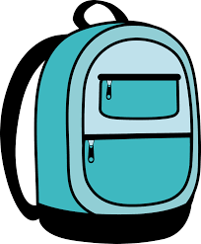 | 1 pair of Blunt-Tip Scissors | 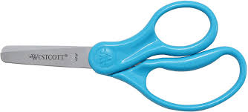
1 pair of sturdy hardwired Headphones  (NO earbuds) | 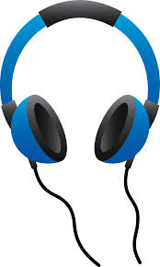 | 2 pack of plain No. 2 pre sharpened pencils | 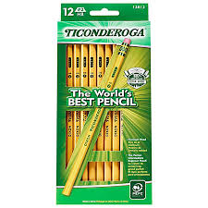
1 Box of Tissues | 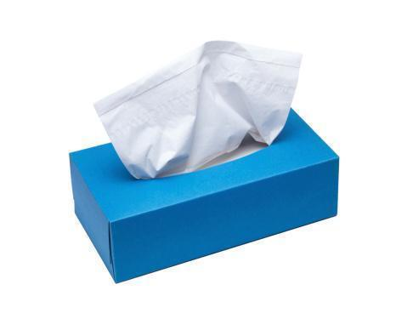 | 12 Glue Sticks  (regular size, nonscented) | 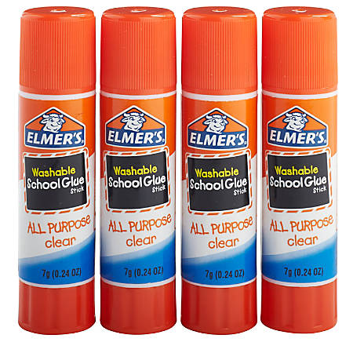
Change of Clothes in a Gallon Storage Bag (including underwear and socks) | 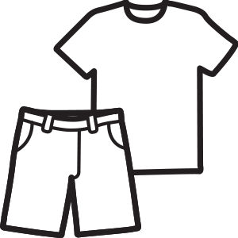 | 4 boxes of 24-count Crayons | 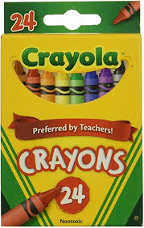
2 pink erasers | 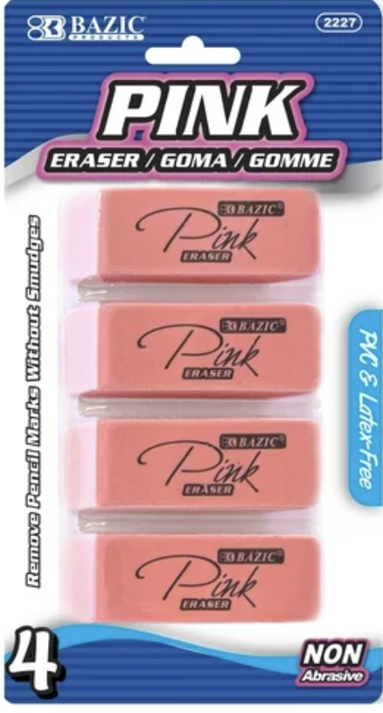 | 1 Spill-Proof Water Bottle (20 oz or less) | 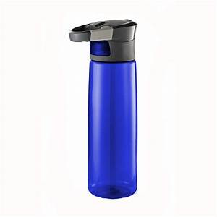
1 4 pack of black dry erase markers | 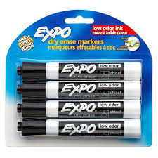 | Highlighters | 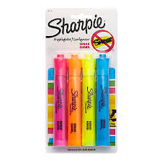
Wish List:
Hand Sanitizer 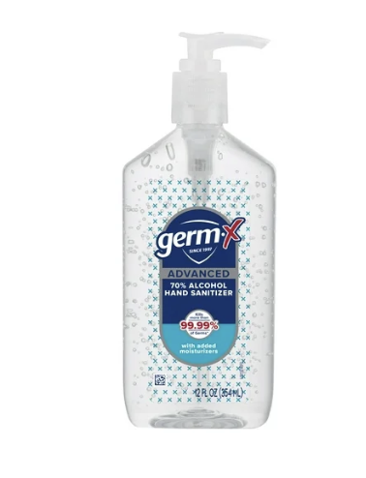Water Color Paint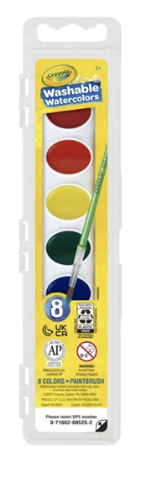 Markers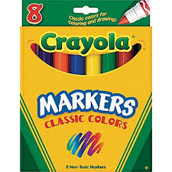Colored Pencils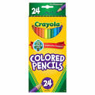Also: paper towels, baby wipes, lysol cleaning wipes, sticky notes and index cards

